# **Table 1. Baseline characteristics after PS stratification**

|  |  |  |  |  |  |  |
| --- | --- | --- | --- | --- | --- | --- |
|  | HCQ vs SSZ | | | AZM vs AMX | | |
|  | HCQ | SSZ |  | AZM | AMX |  |
| Characteristic | % | % | Std. diff | % | % | Std. diff |
| 15-19 | 0.6 | 0.6 | 0.00 | 0.5 | 0.5 | 0.00 |
| 20-24 | 1.8 | 2.0 | -0.01 | 1.4 | 1.4 | 0.00 |
| 25-29 | 2.5 | 2.7 | -0.01 | 2.2 | 2.2 | 0.00 |
| 30-34 | 4.5 | 4.4 | 0.00 | 4.0 | 3.9 | 0.01 |
| 35-39 | 7.1 | 7.1 | 0.00 | 6.8 | 6.7 | 0.00 |
| 40-44 | 9.7 | 9.5 | 0.01 | 9.3 | 9.3 | 0.00 |
| 45-49 | 13.6 | 13.4 | 0.00 | 13.2 | 13.3 | 0.00 |
| 50-54 | 18.2 | 18.0 | 0.01 | 18.1 | 18.0 | 0.00 |
| 55-59 | 20.8 | 20.8 | 0.00 | 21.5 | 21.8 | -0.01 |
| 60-64 | 19.4 | 19.8 | -0.01 | 21.1 | 21.1 | 0.00 |
| 65-69 | 1.8 | 1.6 | 0.01 | 2.0 | 2.0 | 0.00 |
| Gender: female | 80.1 | 79.7 | 0.01 | 86.3 | 86.2 | 0.00 |
| Medical history: General |  |  |  |  |  |  |
| Acute respiratory disease | 35.1 | 34.8 | 0.01 | 58.0 | 57.5 | 0.01 |
| Chronic obstructive lung disease | 4.3 | 4.5 | -0.01 | 5.0 | 5.2 | -0.01 |
| Depressive disorder | 13.3 | 13.5 | 0.00 | 14.7 | 14.8 | 0.00 |
| Diabetes mellitus | 13.6 | 13.8 | -0.01 | 13.2 | 13.1 | 0.00 |
| Hyperlipidemia | 31.2 | 31.4 | 0.00 | 30.4 | 30.3 | 0.00 |
| Pneumonia | 4.0 | 4.0 | 0.00 | 5.7 | 5.5 | 0.01 |
| Renal impairment | 3.0 | 2.8 | 0.01 | 4.2 | 4.1 | 0.00 |
| Urinary tract infectious disease | 11.6 | 11.5 | 0.00 | 14.0 | 13.9 | 0.00 |
| Medical history: Cardiovascular disease |  |  |  |  |  |  |
| Atrial fibrillation | 1.4 | 1.3 | 0.01 | 1.7 | 1.8 | 0.00 |
| Cerebrovascular disease | 2.8 | 2.9 | -0.01 | 3.1 | 3.2 | -0.01 |
| Coronary arteriosclerosis | 4.4 | 4.6 | -0.01 | 5.0 | 4.9 | 0.00 |
| Heart disease | 15.5 | 15.4 | 0.00 | 17.8 | 17.9 | 0.00 |
| Heart failure | 1.9 | 2.0 | 0.00 | 2.5 | 2.4 | 0.01 |
| Ischemic heart disease | 3.0 | 3.1 | -0.01 | 3.3 | 3.1 | 0.01 |
| Medication use |  |  |  |  |  |  |
| Agents acting on the renin-angiotensin system | 24.5 | 24.6 | 0.00 | 27.1 | 26.9 | 0.00 |
| Antidepressants | 36.3 | 36.5 | 0.00 | 43.0 | 42.8 | 0.00 |
| Drugs for obstructive airway diseases | 29.5 | 29.5 | 0.00 | 41.1 | 40.7 | 0.01 |
| Immunosuppressants | 43.4 | 43.6 | 0.00 | 51.1 | 51.2 | 0.00 |
| Opioids | 39.0 | 39.3 | -0.01 | 41.4 | 41.2 | 0.00 |
| Psycholeptics | 33.4 | 33.3 | 0.00 | 38.2 | 38.1 | 0.00 |

# **Table 2. Event occurrence**

|  |  |  |  |  |  |  |  |  |  |  |  |  |  |  |
| --- | --- | --- | --- | --- | --- | --- | --- | --- | --- | --- | --- | --- | --- | --- |
|  |  |  | 30-day follow-up | | | | | | On-treatment follow-up | | | | | |
| Comparison  T vs C | Outcome | Database | Patients | | Events | | IR | | Patients | | Events | | IR | |
|  |  |  | T | C | T | C | T | C | T | C | T | C | T | C |
| HCQ vs SSZ | CV-related mortality | CPRD |  |  |  |  |  |  | 9,127 | 11,398 | 7 | 25 | 0.39 | 0.94 |
| Optum | 51,280 | 17,389 | 16 | <5 | 3.85 | <3.54 | 51,280 | 17,389 | 234 | 25 | 4.39 | 2 |
| VA | 32,028 | 14,349 | 9 | <5 | 3.43 | <4.25 | 32,028 | 14,349 | 315 | 65 | 5.69 | 3.71 |
| Meta-analysis | 83,308 | 31,738 | 25 | <10 | 3.68 | <3.86 | 92,435 | 43,136 | 556 | 115 | 4.39 | 2.03 |
| Chest pain or angina | AmbEMR | 57,140 | 15,268 | 122 | 31 | 26.04 | 24.76 | 57,140 | 15,268 | 451 | 112 | 24.44 | 19.89 |
| CCAE | 65,935 | 22,173 | 440 | 143 | 82.41 | 79.62 | 65,935 | 22,173 | 3,354 | 810 | 55 | 58.8 |
| CPRD | 9,114 | 11,388 | 10 | 17 | 13.4 | 18.22 | 9,114 | 11,388 | 260 | 422 | 14.99 | 16.78 |
| DAGermany | 3,884 | 5,045 | <5 | 5 | <15.69 | 12.07 | 3,884 | 5,045 | 31 | 36 | 12.36 | 10.26 |
| IMRD | 8,843 | 8,452 | 9 | 10 | 12.45 | 14.46 | 8,843 | 8,452 | 235 | 293 | 14 | 16.25 |
| MDCD | 7,982 | 2,177 | 80 | 23 | 123.5 | 130.43 | 7,982 | 2,177 | 467 | 100 | 87.34 | 85.81 |
| MDCR | 15,690 | 5,150 | 129 | 49 | 101.25 | 117.43 | 15,690 | 5,150 | 1,178 | 279 | 71.38 | 75.12 |
| OpenClaims | 617,628 | 182,776 | 2,674 | 804 | 52.83 | 53.68 | 617,628 | 182,776 | 31,161 | 6,198 | 38.59 | 38.11 |
| Optum | 50,698 | 17,221 | 396 | 166 | 96.62 | 119.34 | 50,698 | 17,221 | 3,185 | 829 | 66.13 | 72.48 |
| PanTher | 76,844 | 21,549 | 629 | 143 | 101.46 | 82.23 |  |  |  |  |  |  |
| VA | 31,824 | 14,276 | 130 | 54 | 49.89 | 46.2 | 31,824 | 14,276 | 1,822 | 611 | 35.88 | 37.31 |
| Meta-analysis | 945,582 | 305,475 | <4,624 | 1,445 | <59.86 | 57.9 | 868,738 | 283,926 | 42,144 | 9,690 | 40.36 | 37.07 |
| Heart failure | AmbEMR | 57,383 | 15,305 | 42 | 10 | 8.92 | 7.96 | 57,383 | 15,305 | 182 | 53 | 9.76 | 9.37 |
| CCAE | 66,604 | 22,370 | 30 | 5 | 5.55 | 2.75 | 66,604 | 22,370 | 305 | 74 | 4.64 | 5.07 |
| CPRD | 9,126 | 11,397 | <5 | <5 | <6.69 | <5.35 | 9,126 | 11,397 | 16 | 36 | 0.89 | 1.36 |
| DAGermany | 3,885 | 5,042 | <5 | <5 | <15.68 | <12.08 | 3,885 | 5,042 | 11 | 22 | 4.29 | 6.22 |
| IMRD | 8,852 | 8,460 | <5 | <5 | <6.91 | <7.22 | 8,852 | 8,460 | 15 | 21 | 0.86 | 1.11 |
| MDCD | 8,072 | 2,195 | 15 | <5 | 22.81 | <27.99 | 8,072 | 2,195 | 118 | 28 | 20.55 | 23.02 |
| MDCR | 15,808 | 5,171 | 39 | 19 | 30.3 | 45.22 | 15,808 | 5,171 | 586 | 141 | 33.13 | 36.29 |
| OpenClaims | 620,244 | 183,350 | 749 | 214 | 14.71 | 14.22 | 620,244 | 183,350 | 12,246 | 2,246 | 14.36 | 13.22 |
| Optum | 51,204 | 17,356 | 84 | 25 | 20.23 | 17.76 | 51,204 | 17,356 | 915 | 207 | 17.55 | 16.9 |
| PanTher | 77,813 | 21,768 | 237 | 50 | 37.64 | 28.39 |  |  |  |  |  |  |
| VA | 31,895 | 14,307 | 56 | 17 | 21.42 | 14.49 | 31,895 | 14,307 | 897 | 296 | 16.75 | 17.42 |
| Meta-analysis | 950,886 | 306,721 | <1,267 | <360 | <16.28 | <14.34 | 873,073 | 284,953 | 15,291 | 3,124 | 13.85 | 11.43 |
| AZM vs AMX | CV-related mortality | Optum | 23,597 | 24,521 | 9 | 6 | 4.7 | 3.02 | 23,597 | 24,521 | 96 | 82 | 5.56 | 5.58 |
| VA | 6,234 | 8,005 | 46 | 18 | 90.6 | 27.49 | 6,234 | 8,005 | 157 | 115 | 14.6 | 10.2 |
| Meta-analysis | 29,831 | 32,526 | 55 | 24 | 22.7 | 9.08 | 29,831 | 32,526 | 253 | 197 | 9.03 | 7.59 |
| Chest pain or angina | AmbEMR | 13,093 | 12,028 | 32 | 21 | 29.8 | 21.29 | 13,093 | 12,028 | 142 | 119 | 25.69 | 25.31 |
| CCAE | 32,165 | 32,229 | 241 | 211 | 92.76 | 80.98 | 32,165 | 32,229 | 1,402 | 1,145 | 60.46 | 60.54 |
| MDCD | 3,712 | 3,764 | 30 | 37 | 99.97 | 121.56 | 3,712 | 3,764 | 129 | 113 | 60.05 | 63.39 |
| MDCR | 7,991 | 9,195 | 81 | 85 | 125.6 | 114.2 | 7,991 | 9,195 | 517 | 498 | 74.83 | 71.25 |
| OpenClaims | 214,494 | 231,851 | 1,050 | 888 | 59.76 | 46.74 | 214,494 | 231,851 | 8,348 | 7,223 | 36.24 | 36.37 |
| Optum | 23,206 | 24,254 | 244 | 203 | 130.28 | 103.7 | 23,206 | 24,254 | 1,019 | 887 | 70.33 | 70.28 |
| PanTher | 18,039 | 16,191 | 218 | 134 | 150.01 | 102.42 |  |  |  |  |  |  |
| VA | 6,121 | 7,912 | 58 | 50 | 116.96 | 77.52 | 6,121 | 7,912 | 340 | 371 | 38.48 | 39.87 |
| Meta-analysis | 318,821 | 337,424 | 1,954 | 1,629 | 75.13 | 59.12 | 300,782 | 321,233 | 11,897 | 10,356 | 40.82 | 40.95 |
| Heart failure | AmbEMR | 13,152 | 12,053 | 16 | 16 | 14.83 | 16.18 | 13,152 | 12,053 | 61 | 49 | 10.44 | 9.96 |
| CCAE | 32,586 | 32,496 | 30 | 23 | 11.36 | 8.73 | 32,586 | 32,496 | 177 | 126 | 6.58 | 5.82 |
| MDCD | 3,796 | 3,795 | 16 | 9 | 52.08 | 29.21 | 3,796 | 3,795 | 65 | 48 | 26.26 | 24.83 |
| MDCR | 8,085 | 9,239 | 45 | 33 | 68.88 | 43.97 | 8,085 | 9,239 | 322 | 295 | 41.61 | 38.34 |
| OpenClaims | 215,732 | 232,725 | 472 | 370 | 26.68 | 19.38 | 215,732 | 232,725 | 4,352 | 3,714 | 17.5 | 17.43 |
| Optum | 23,541 | 24,468 | 65 | 49 | 34.08 | 24.73 | 23,541 | 24,468 | 337 | 317 | 20.33 | 22.63 |
| PanTher | 18,054 | 16,298 | 99 | 60 | 67.77 | 45.45 |  |  |  |  |  |  |
| VA | 6,164 | 7,959 | 79 | 31 | 158.53 | 47.73 | 6,164 | 7,959 | 280 | 229 | 28.17 | 21.64 |
| Meta-analysis | 321,110 | 339,033 | 822 | 591 | 31.32 | 21.32 | 303,056 | 322,735 | 5,594 | 4,778 | 17.58 | 17.44 |

# **Figure 1. Source-specific and meta-analytic cardiovascular risk estimates for hydroxychloroquine vs sulfasalazine and azithromycin vs amoxicillin new users during 30-day follow-up**

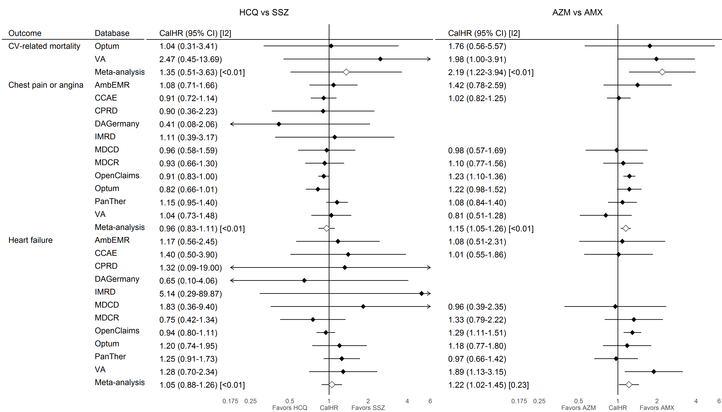

HCQ=hydroxychloroquine; SSZ=sulfasalazine; AZM=azithromycin (plus concurrent hydroxychloroquine exposure); AMX=amoxicillin (plus concurrent hydroxychloroquine exposure); CalHR=calibrated hazard ratio; CI=confidence interval; I2=estimate heterogeneity statistic; AmbEMR=IQVIA Ambulatory EMR; CCAE=IBM Commercial Database; CPRD=Clinical Practice Research Datalink, DAGermany=IQVIA Disease Analyzer Germany; IMRD=IQVIA UK Integrated Medical Record Data; MDCD=IBM IBM Multi-state Medicaid; MDCR=IBM Medicare Supplemental Database; OpenClaims=IQVIA Open Claims; Optum=Optum Clinformatics Datamart; PanTher=Optum PanTherapeutic Electronic Health Record; VA=Veteran’s Health Administration Database. AZM vs AMX comparisons in CPRD, DAGermany, and IMRD did not meet study diagnostic criteria so estimates are not reported.

# **Figure 2. Source-specific and meta-analytic cardiovascular risk estimates for hydroxychloroquine vs sulfasalazine and azithromycin vs amoxicillin new users during on-treatment follow-up**

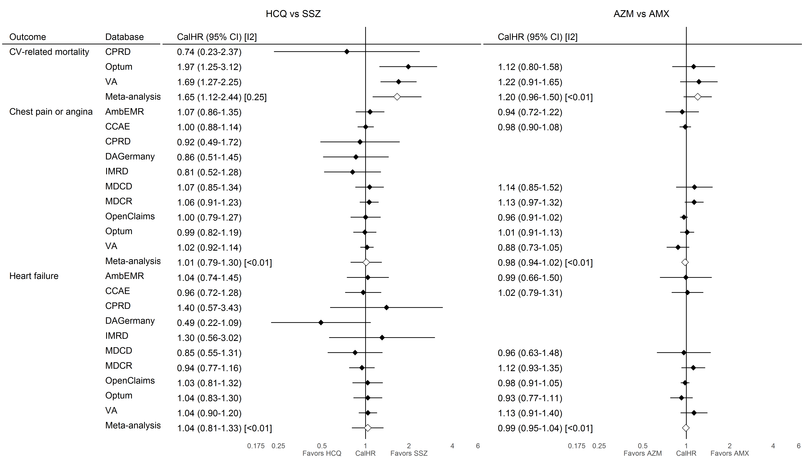

HCQ=hydroxychloroquine; SSZ=sulfasalazine; AZM=azithromycin (plus concurrent hydroxychloroquine exposure); AMX=amoxicillin (plus concurrent hydroxychloroquine exposure); CalHR=calibrated hazard ratio; CI=confidence interval; I2=estimate heterogeneity statistic; AmbEMR=IQVIA Ambulatory EMR; CCAE=IBM Commercial Database; CPRD=Clinical Practice Research Datalink, DAGermany=IQVIA Disease Analyzer Germany; IMRD=IQVIA UK Integrated Medical Record Data; MDCD=IBM IBM Multi-state Medicaid; MDCR=IBM Medicare Supplemental Database; OpenClaims=IQVIA Open Claims; Optum=Optum Clinformatics Datamart; PanTher=Optum PanTherapeutic Electronic Health Record; VA=Veteran’s Health Administration Database. AZM vs AMX comparisons in CPRD, DAGermany, and IMRD did not meet study diagnostic criteria so estimates are not reported. On-treatment follow-up information was not available in the PanTher database.

# **Figure 3. Meta-analytic cardiovascular risk estimates for hydroxychloroquine vs sulfasalazine and azithromycin vs amoxicillin new users during on-treatment during 30-day and on-treatment follow-up**

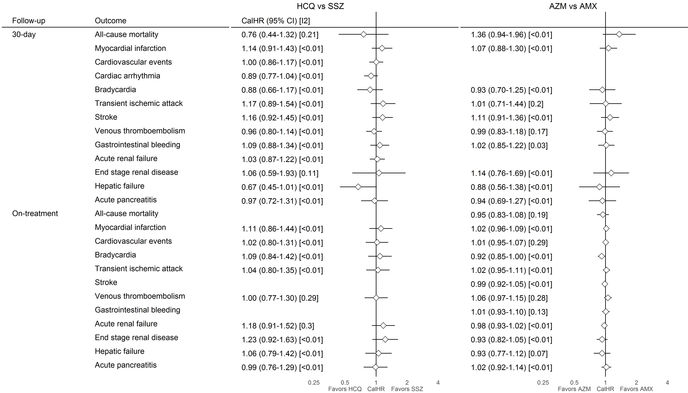

HCQ=hydroxychloroquine; SSZ=sulfasalazine; AZM=azithromycin (plus concurrent hydroxychloroquine exposure); AMX=amoxicillin (plus concurrent hydroxychloroquine exposure); CalHR=calibrated hazard ratio; CI=confidence interval; I2=estimate heterogeneity statistic. Meta-analytic estimates reported where I2<0.4. All database-specific estimates are reported in Appendix Tables S9.1-S9.X